



**Module Code & Module Title**

**CS6P05NI Final Year Project**

**Assessment Weightage & Type**

**40% FYP Final Report**

**Semester**

**2021 Autumn**

**Project Title: Rent Management Web app, Tarif**

**Student Name: Suyogya Luitel**

**London Met ID: 19031784**

**College ID: np01cp4a190035**

**Internal Supervisor: Mohit Sharma**

**External Supervisor: Ankit Tandukar**

**Assignment Due Date:**

**Assignment Submission Date:**

**Word Count (Where Required):**

*I confirm that I understand my coursework needs to be submitted online via Google Classroom under the relevant module page before the deadline in order for my assignment to be accepted and marked. I am fully aware that late submissions will be treated as non-submission and a mark of zero will be awarded.*

**Abstract**

This report demonstrates the early phases of the development of the Rent Management Web app based on React and Django. Even as the world has entered the stage of electronic data storage, people in the rental domain still either keep a record of rent data on paper or do not store it at all. Keeping in mind the importance of data analysis to make educated decisions, this project aims to digitally store the rental data of the users and also make it easier to find houses to rent.

**Table of Contents**

1. Introduction 1

1.1. Introduction to the Topic 1

1.2. Current Scenario 1

1.2.1. World 1

1.2.2. Nepal 3

1.3. Problem Scenario 4

1.4. Project as solution 4

1.5. Aim and Objectives: 5

1.5.1. Aim 5

1.5.2. Objectives 5

1.6. Report Structure 6

1.6.1. Background 6

1.6.2. Development 6

1.6.3. Testing 6

1.6.4. Conclusion 6

2. Background 7

2.1. Client description and requirements 7

2.1.1. Description 7

2.1.2. Requirements 7

2.2. Understanding the project 10

2.2.1. Web app as a medium 10

2.2.2. Project elaboration 10

2.2.3. Project deliverables 10

2.3. Similar systems 12

2.3.1. System 1: Onsite Property Manager 12

2.3.2. System 2: Vacationlabs 14

2.3.3. System 3: Buildium 15

2.3.4. System 4: Neopropertynepal 17

2.3.5. System 5: Property Care Guru 19

2.4. Similar Systems Comparison 22

2.4.1. Comparison Table 22

2.4.2. Comparison Result 22

3. Development 23

3.1. Considered Methodologies 23

3.1.1. Iterative Waterfall 23

3.1.2. Prototyping 24

3.1.3. Feature Driven Development 25

3.2. Adopted Methodology (FDD) 27

3.3. Phases of Adopted Methodology 28

3.3.1. Initiation 28

3.3.2. Overall Model 28

3.3.3. Feature List 28

3.3.4. Plan by Feature 29

3.3.5. Design by Feature 29

3.3.6. Build by Feature 30

3.4. Survey Results 30

3.4.1. Presurvey Results: 30

3.4.2. Postsurvey Results 35

3.4.3. UI Designs 38

3.4.4. Use Case Diagram 46

4. References 56

5. Appendix 58

5.1. Appendix A (Development) 58

5.1.1. Gant Chart 58

5.1.2. Work Breakdown Structure 59

5.2. Appendix B (Development Till Date) 60

5.2.1. Code Snippets 60

5.2.2. Viewable Development 65

**Table of Figures**

Figure 1: North American Market size and projection (Fortune Business Insights, 2021) 2

Figure 2: Similar System 1 12

Figure 3: Similar system 1.1 13

Figure 4: Similar system 1.2 13

Figure 5: Similar system 2.2 15

Figure 6: Similar System 2.3 15

Figure 7: System 3 16

Figure 8: System 3.1 16

Figure 9: System 3.2 17

Figure 10: System 4 18

Figure 11: System 4.1 18

Figure 12: System 4.2 19

Figure 13: System 5 20

Figure 14: System 5.1 20

Figure 15: System 5.2 21

Figure 16: Iterative waterfall model (Ruparelia, 2010) 23

Figure 17: Prototyping Model (Martin, 2021) 24

Figure 18: FDD project Lifecycle (Abler, 2021) 26

Figure 19: Presurvey result 1 30

Figure 20: Presurvey Result 2 31

Figure 21: Presurvey Result 3 31

Figure 22: Presurvey Result 4 32

Figure 23: Presurvey Result 5 32

Figure 24: Presurvey Result 6 33

Figure 25: Presurvey Result 7 33

Figure 26: Presurvey Result 8 34

Figure 27: Postsurvey Results 1 35

Figure 28: Postsurvey Results 2 35

Figure 27: Postsurvey Results 3 36

Figure 27: Postsurvey Results 4 36

Figure 27: Postsurvey Results 5 37

Figure 27: Postsurvey Results 6 37

Figure 29: Sign-in page UI 38

Figure 30: Sign up page UI 39

Figure 31: Home Page UI 40

Figure 32: Houses page UI 41

Figure 33: Bills page UI 42

Figure 34: Analysis page UI 43

Figure 35: Profile page UI 44

Figure 36: Map page UI 45

Figure 37: Use Case Diagram 46

Figure 38: Updated Gantt Chart 58

Figure 39: Gantt chart Tasks for Clarity 58

Figure 40: Work Breakdown Structure 59

Figure 41: App.js Code 60

Figure 42: App.css Code 61

Figure 43: Button Component Code 62

Figure 44: Login form Code 62

Figure 45: Button style Code 63

Figure 46: Login Page Code 64

Figure 47: Sign-in page 65

**Table of Tables**

Table 1: System Comparison Table 22

Table 2: Initiation of Project 28

Table 3: Developing Overall Model of Project 28

Table 4: Developing Overall Model of Project 29

Table 5: Developing Overall Model of Project 29

Table 6: Developing Overall Model of Project 29

Table 7: Developing Overall Model of Project 30

# 

# Introduction

## Introduction to the Topic

Web apps have revolutionized the way we use the internet. While initially, web browsers could only render simple HTML contents, nowadays browsers are powerful enough to run heavy web apps and even heavy 3D RPG games, thanks to the JavaScript engines built into browsers. People use the internet very frequently, making it the perfect platform for reaching a huge mass of people. The beauty of a web app is that it runs on any platform so long as you have an internet connection and a browser, be it IOS, Windows, Android, Linux, or any other OS. Using a web app, both the tenants and householders can find one another more easily and communicate. The ratings help both the tenants and householders in screening the available options.

## Current Scenario

### World

According to a report on property management market by Fortune Business Insights, the global property management market size was USD 13.88 billion in 2020 (Fortune Business Insights, 2021). While the COVID-19 affected the whole world in a catastrophic way, property management software/services witnessed a positive demand shock across all regions. Based on their analysis, the global market exhibited a significant growth of 8.7% in 2020 as compared to year-on-year growth during 2017-2019 and the market is expected to grow from USD 15.10 billion in 2021 to USD 28.21 billion in 2028 at a CAGR (Compound Annual Growth Rate) of 9.3% in the 2021-2028 period (Fortune Business Insights, 2021). The steady rise in CAGR as attributable to this market’s demand and growth, returning to pre-pandemic levels once the pandemic is over.

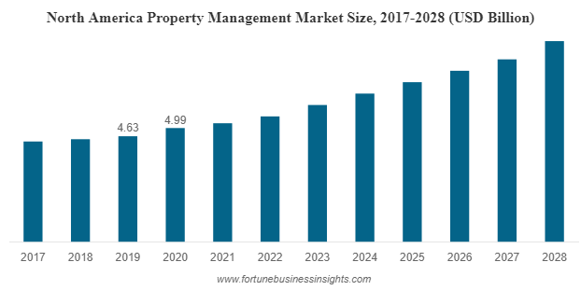

Figure 1: North American Market size and projection (Fortune Business Insights, 2021)

### Nepal

In case of Nepal, the pandemic made people more aware and enthusiastic about cashless payment options in. While managing rents looks trivial at a first glance, it can get out of hand very quickly if multiple properties are to be put on rent. Besides, traditionally in Nepal, people either do not keep a record of the rents they push or pay; or record it on paper. Keeping a record of rents is extremely useful as it can provide statistical benefits. Comparing the rents paid for different houses can give one an idea of what the market is offering them which can be used in decision making while searching for rents. On the flip side, keeping tabs of bills pushed or rent collected can be valuable to householders to gauge what people are willing to pay and what their property’s worth should be to tenants. By keeping a record of rents paid/collected, the users can make educated decisions about what properties are worth and what amount they should be paying.

## P**roblem Scenario**

The problems that the web app intends to solve are as follows:

1. Finding a rent or finding a tenant is difficult given the limited means of reaching out to one another in Nepal.
2. People are opting to spend money via cashless means due to the pandemic. However, house rents are paid mostly via cash when the householder visits the tenant door to door.
3. Pushing consistent bills to tenants takes quite a bit of time as householders mostly need to do all the calculations themselves, write it all down on a piece of paper, sign it, and manually send it to tenants.
4. While pushing a bill or paying a bill, most of the parties involved in house rents, do not keep track of the transactions being made. That is ignorance of data which could serve as a valuable asset in decision making.
5. Often there is no reliable way for screening available options of householders and tenants. Thus, after a contract is signed, either party could end up stuck with a bad or unwanted company.

## Project as solution

The project solves the aforementioned issues by the following means:

1. The app displays a map-based view which helps users locate houses ready to be rented. Similarly, since the houses are now viewable on a map, the householders can find tenants more frequently.
2. The app provides a cashless means to pay rent if the user desires to do so.
3. The app supports the development of a bill template which the householders can then use to push consistent bills to all tenants.
4. The app keeps track of all rent-related transactions and visualizes the data in form of a graph so that the user can make educated decisions.

The app supports ratings and reviews which help in screening both tenants and householders.

## Aim and Objectives:

### Aim

The major aim of the project is to make finding and managing rents easier. The project helps tenants find reliable rent and help householders find reliable tenants. To help tenants and householders make educated guesses based on their previous data. To provide tenants and householders a reliable way to pay and push bills respectively via e-payment.

### Objectives

The objectives of this web app are:

* To learn about web development and its required paradigms
* To learn about database designing in a real-world scenario
* To learn how restful APIs work
* To better understand third-party APIs in development such as map APIs.
* To better understand frontend technologies like react, and JS in general.
* To better understand backend technologies such as Django and Django REST framework.

## Report Structure

### Background

The background section of the report clarifies the project requirements, project description, and end-users. The section also covers a comparison of the project with other similar projects to establish how the project is different from some of the existing solutions.

### Development

The development section of the report elaborates how the project is to be developed. The section also covers the considered and selected methodologies while also describing the several phases of the selected methodology. The development process is also visually represented with the help of the Work Breakdown Structure and Gantt Chart.

### Testing

This section consists of the process related to unit testing, integration testing, and customer evaluation testing.

### Conclusion

This section consists of information related to the supposition of the report, a review of wider implications, and future improvements of the project.

# Background

## Client description and requirements

Client name: Saral Karki

### Description

The client is Saral Karki, an individual, who resides in a rental house and wants a web app to enhance their rent experience. Having experienced rental issues first-hand, the client knows the common issues faced in the house rental domain.

Upon presenting this project to Saral, he found the project helpful in resolving the issues he has seen in the house rental domain. He agreed to be the client for this project as he sees practicability in the project and is thus willing to provide his insight on the rental domain.

### Requirements

According to the meeting with the client, the following requirements were declared as mandatory:

1. **The householder and Tenant registration with citizenship**

The user registers as a householder or a tenant. While registering, the user must upload a scanned copy of their citizenship which is also stored for security purposes. While it is not a common practice in Nepal for householders to take a copy of the tenant’s citizenship, it is a good practice to have it available. Having citizenship attached to an account also significantly reduces the chances of fraud or run-away cases.

1. **Houses must be visible on a map**

The web app must contain a map displaying the houses available for rent which is visible to users after they sign in. This makes it easier for tenants to find houses for rent in their desired location.

1. **Push bills as a householder**

The web app must enable householders to make house bills and push the bills via email. This makes it easier to calculate the rent amount as well as removes the hassle of physically visiting the tenant or handing out bills.

1. **Pay bills as Tenant**

The pushed bills must have an e-payment option so that tenants can pay the bills virtually. This removes the hassle of physically meeting the householder just for paying the rent amount.

1. **Reviews**

The initial proposed idea was that both householders and tenants must be able to leave a rating on one another after their term has ended. This ensures that there is a way for screening the tenants/householders even before the interview takes place.

However, upon a later call from the client, it was stated that having reviews on people can cause demoralization if the ratings go low. It would eventually cause the user to stop using the rental app if their rating plummeted. Thus, the feature was modified to allow tenants to review houses.

1. **Register houses as a householder**

A householder must be able to have multiple houses registered since a user may have multiple houses.

1. **Keep track of payment amounts and dates**

The web app must also ensure that it stores bill details and bill dates paid by each user.

1. **Visualize user data for educated decision making.**

The web app must visualize the given user data in form of a graph to enable educated decision making.

The client also mentioned a communication portal for tenants and householders as an optional feature if possible.

## Understanding the project

### Web app as a medium

Web apps have revolutionized the way we use the internet. While initially, web browsers could only render simple HTML contents, nowadays browsers are powerful enough to run heavy web apps and even heavy 3D RPG games, thanks to the JavaScript engines built into browsers. People use the internet very frequently, making it the perfect platform for reaching a huge mass of people. The beauty of a web app is that it runs on any platform so long as you have an internet connection and a browser, be it IOS, Windows, Android, Linux, or any other OS.

### Project elaboration

The project is a web app built using React and Django frameworks. React is the frontend framework used for making the project viewable in the browser and to collect input from the users. Django is the backend framework for storing user information. The project uses restful APIs to transfer data between the backend and the frontend. The web app registers users as a householder or a tenant. Upon sign in, they are given access to further features such as finding available houses, registering available houses, e-payment for bills, and a communication portal. Once both the householder and the tenant have selected one another, the house is marked rented, and this term can be ended by the householder. After the term has ended, the house is marked again as available.

### Project deliverables

The expected outcomes and deliverables of the web app are:

* The householder and Tenant registration with citizenship
* Houses must be visible on a map
* Push bills as a householder
* Pay bills as Tenant
* Reviews
* Register houses as a householder
* Keep track of payment amounts and dates
* Visualize user data for educated decision making.

### Technical terms and definition

#### IDE

Visual Studio Code is a lightweight but powerful source code editor which runs on your desktop and is available for Windows, macOS and Linux (Visual Studio, 2022). It comes with built-in support for JavaScript, TypeScript and Node.js and has a rich ecosystem of extensions for other languages (such as C++, C#, Java, Python, PHP, Go) and runtimes (such as .NET and Unity).

#### Database

##### SQLite

SQLite is an in-process library that implements a self-contained, serverless, zero-configuration, transactional SQL database engine. The code for SQLite is in the public domain and is thus free for use for any purpose, commercial or private. SQLite is the most widely deployed database in the world with more applications than we can count, including several high-profile projects. (SqLite, 2022)

#### Frontend Framework

##### React

React is a JavaScript library for building user interfaces. React has been designed from the start for gradual adoption, and can be used as little or as much as the user needs. Whether to get a taste of React, add some interactivity to a simple HTML page, or start a complex React-powered app, React provides a platform to the user. (React, 2022)

#### Backend Framework

##### Django

Django is a python framework developed in a fast-paced newsroom environment, designed to make common web development tasks fast and easy. (Django, 2022)

## Similar systems

### System 1: Onsite Property Manager

URL: <http://www.onsitepropertymanager.com/>

This system manages property rental with automated postings, rent roll format, and Tenant portals. However, it does not have the feature to help tenants find householders or rent. It is also not free to use and has paid plans starting at $6.95.

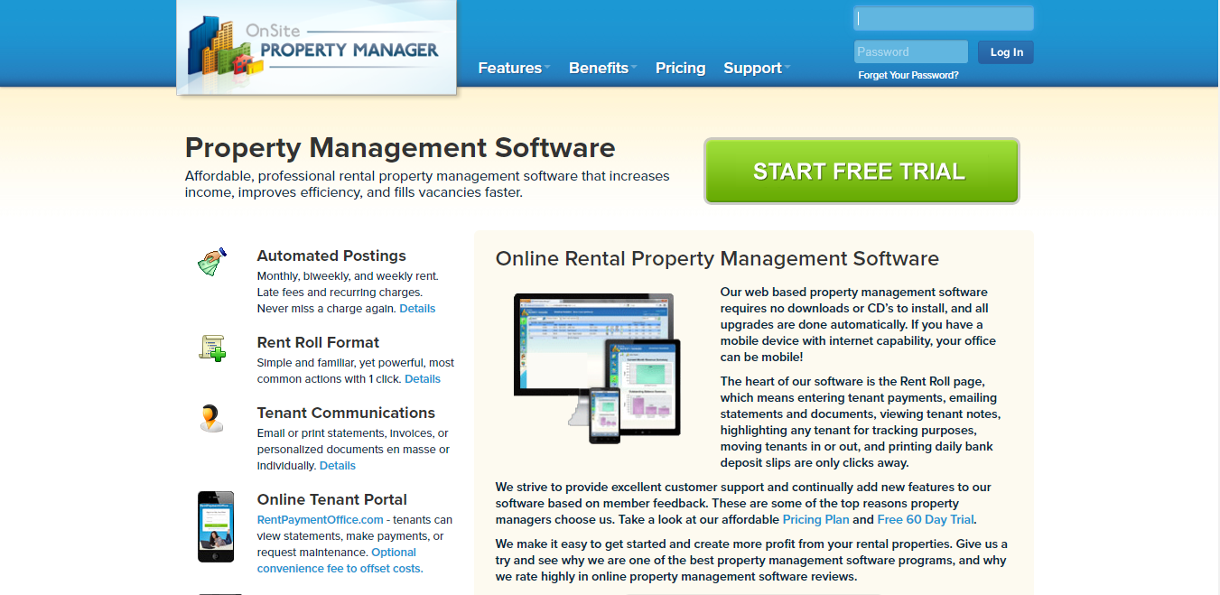

Figure 2: Similar System 1

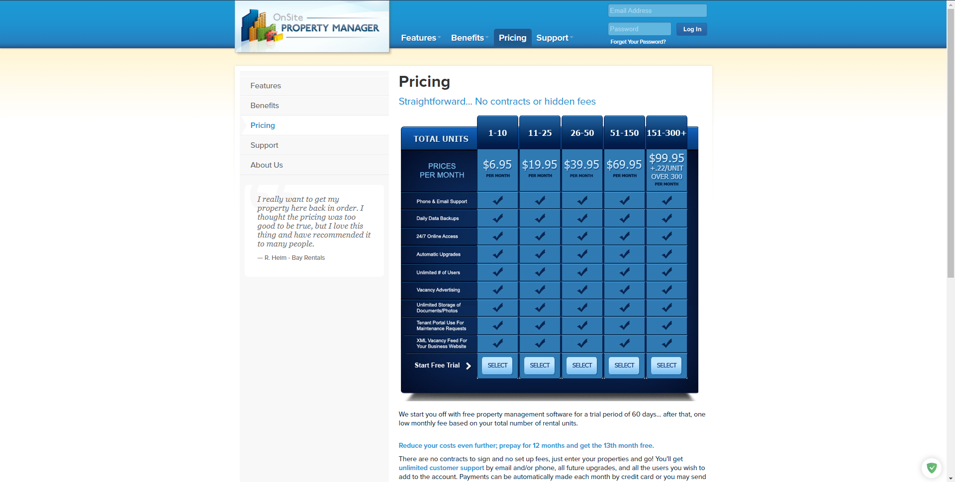

Figure 3: Similar system 1.1

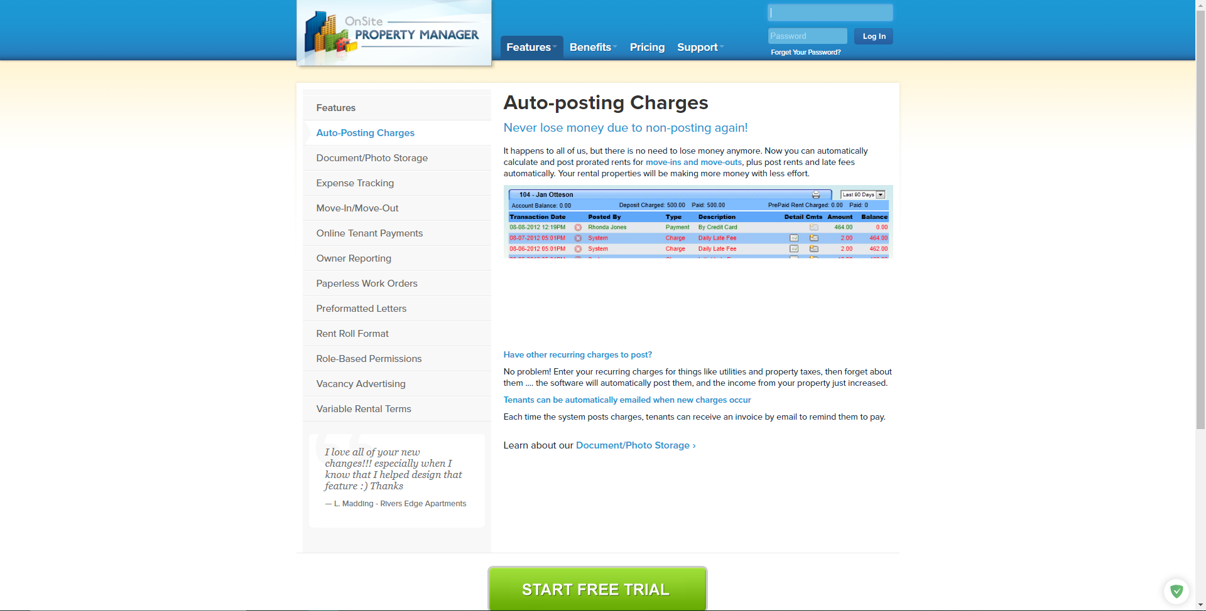

Figure 4: Similar system 1.2

### System 2: Vacationlabs

URL: <https://www.vacationlabs.com/rental-management-system/>

This system handles vacation-related rentals such as hotels, tours, etc. While residing in the property rental domain, this system arranges temporary rents for tour and travels. It does not solve the issue of tenants and householders.

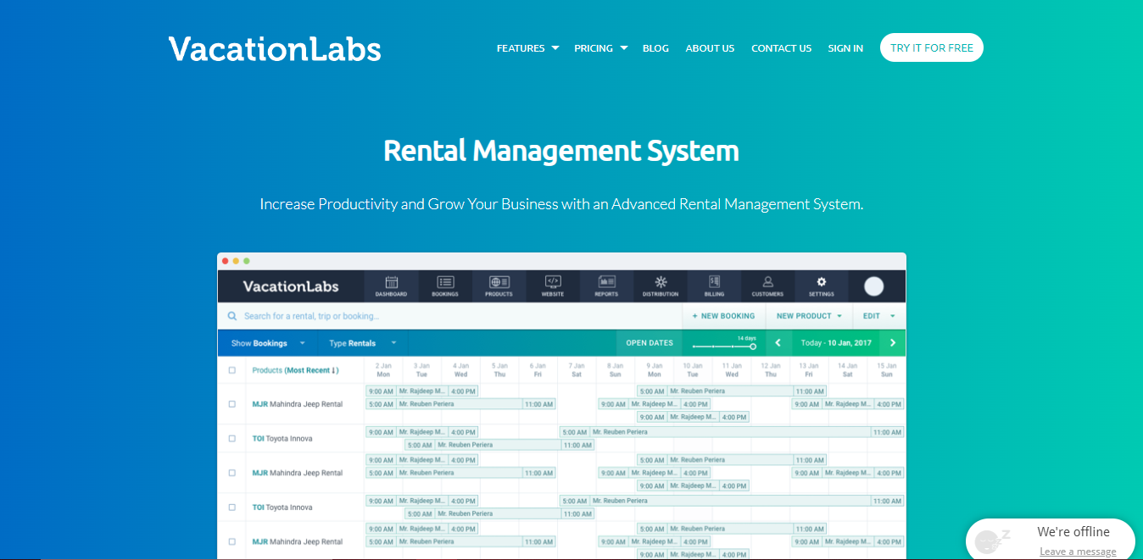

Figure: System 2

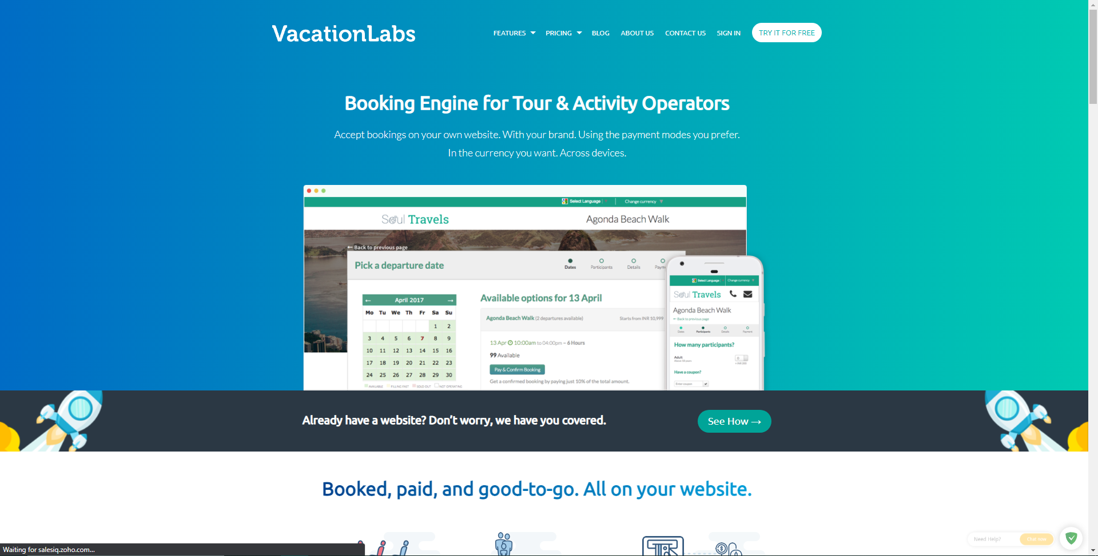

Figure 5: Similar system 2.2

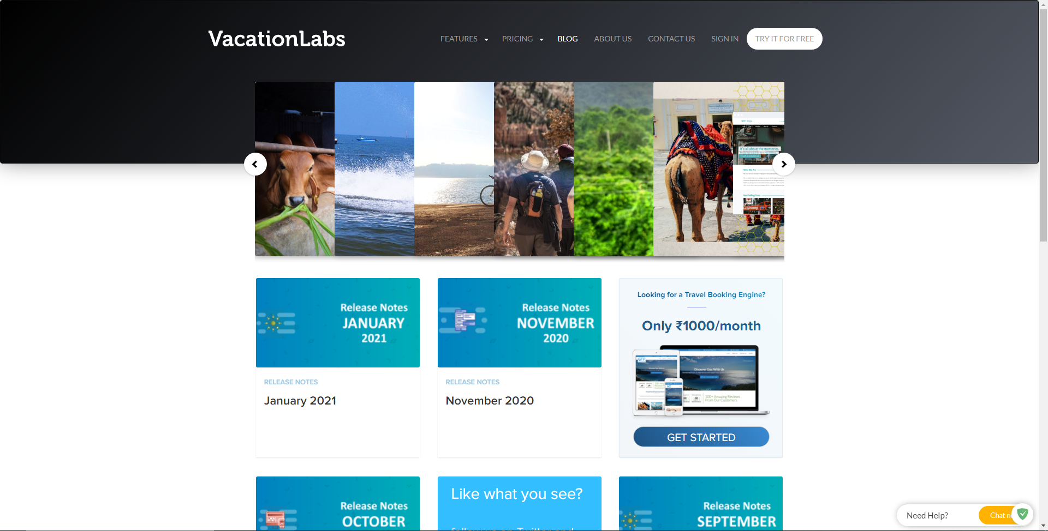

Figure 6: Similar System 2.3

### System 3: Buildium

URL: <https://learn.buildium.com/>

This system is a pay-to-use system that helps in ePay, Tenant Screening, Renters Insurance, and data visualization reports. While the system is great, it is not used in the case of Nepal since it is a pay-to-use system with a rather high price plan starting at $50 per month.

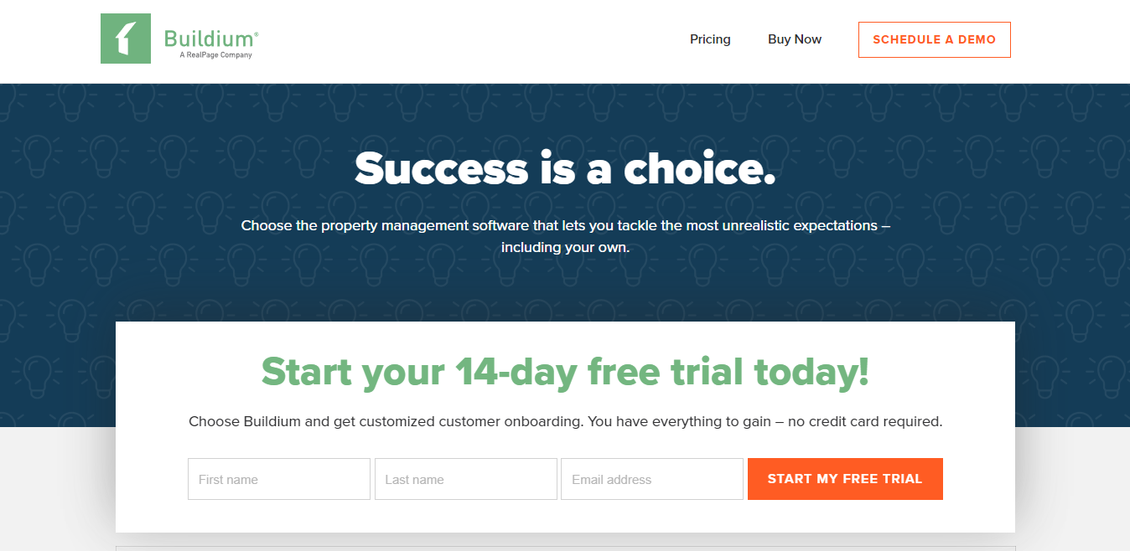

Figure 7: System 3

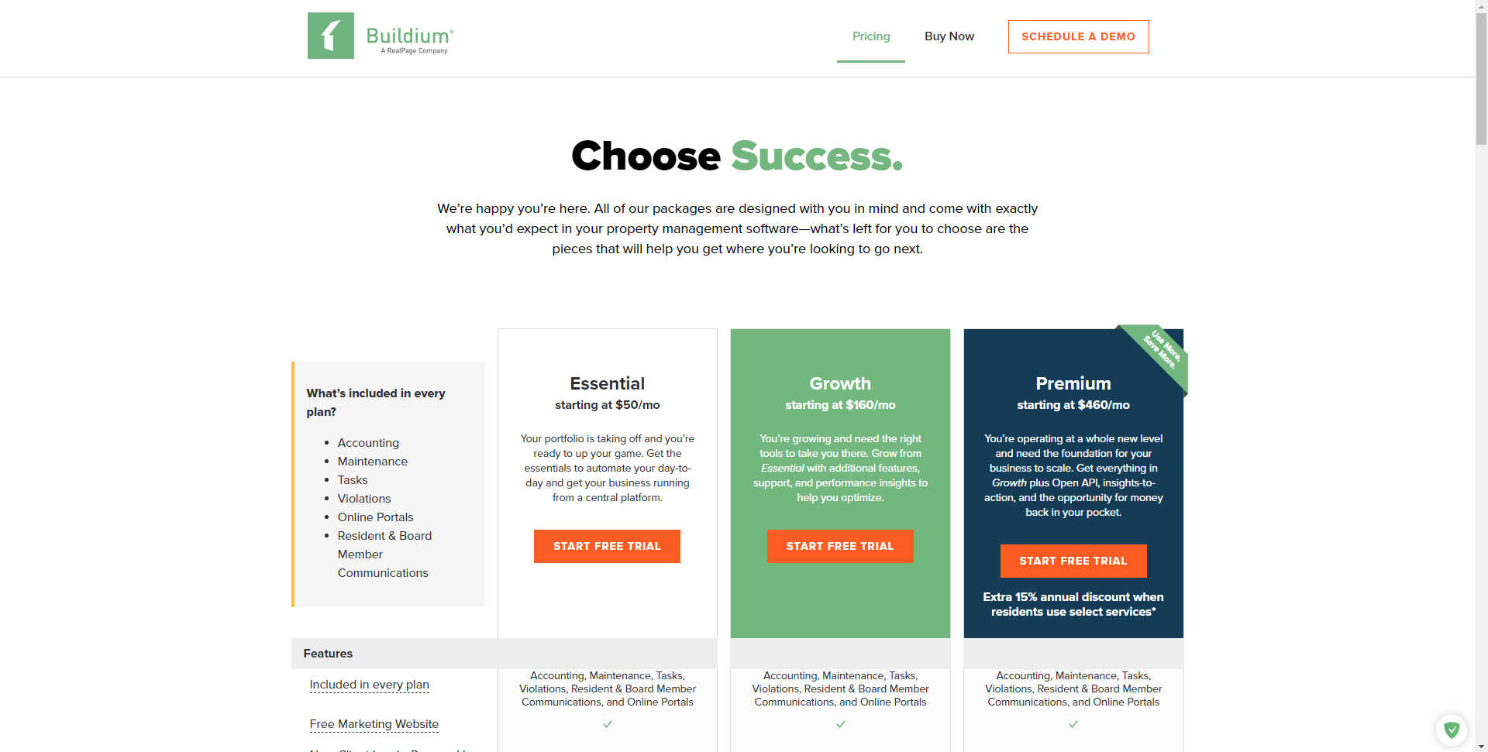

Figure 8: System 3.1

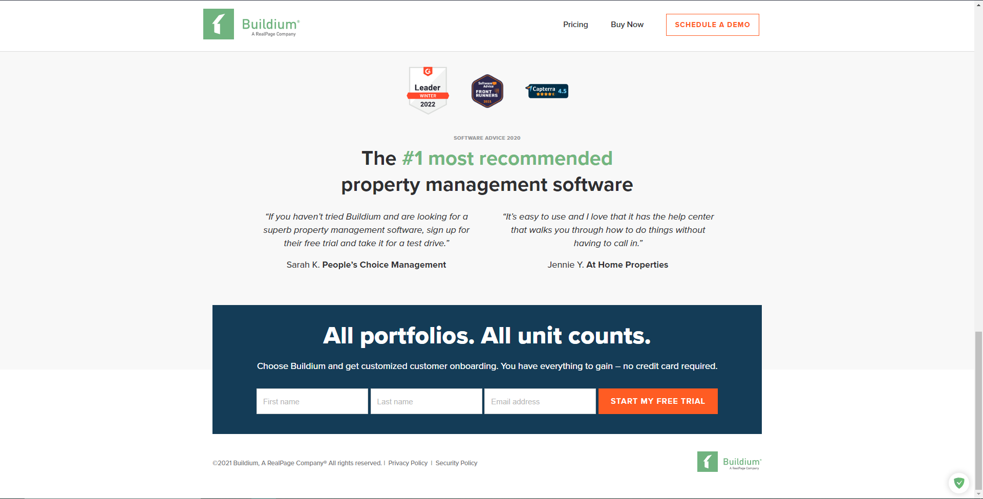

Figure 9: System 3.2

### System 4: Neopropertynepal

URL: <https://www.neopropertynepal.com/>

This system is based in Nepal and helps users with property sales and rental. It includes houses, offices, land, hotel, apartments, etc. While the app is great, it cannot be used for tenant or householder filtering since it shows advertisement-based property and has no system for rating.

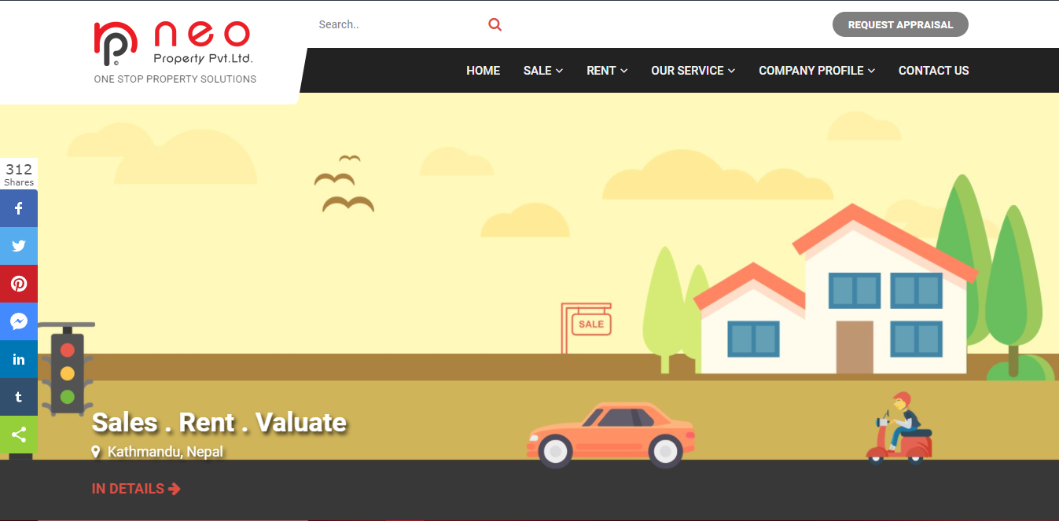

Figure 10: System 4

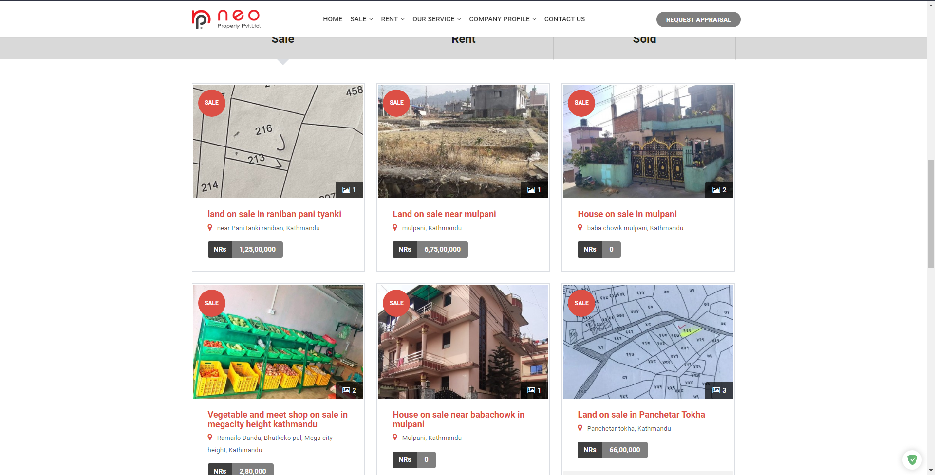

Figure 11: System 4.1

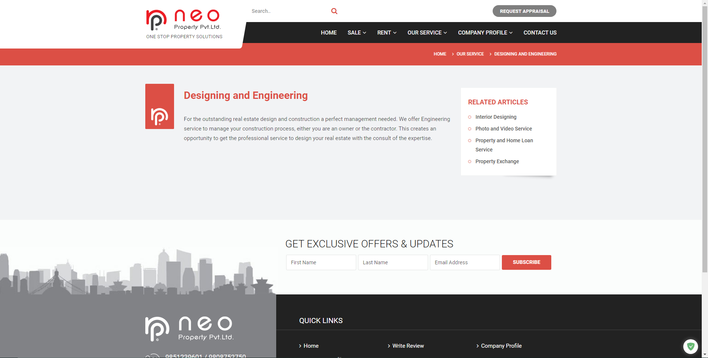

Figure 12: System 4.2

### System 5: Property Care Guru

URL: <http://propertycareguru.com/>

This system is also based in Nepal and helps users find vacant properties. The app has a lot of property filtering options but similar to the previous system, has no feature for rating and reviewing.

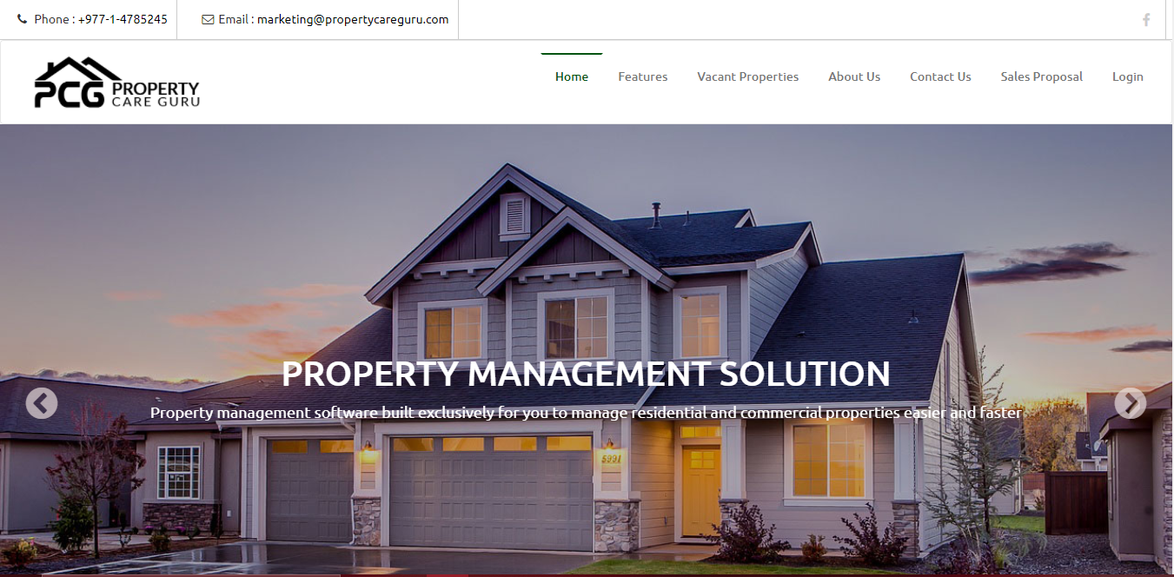

Figure 13: System 5

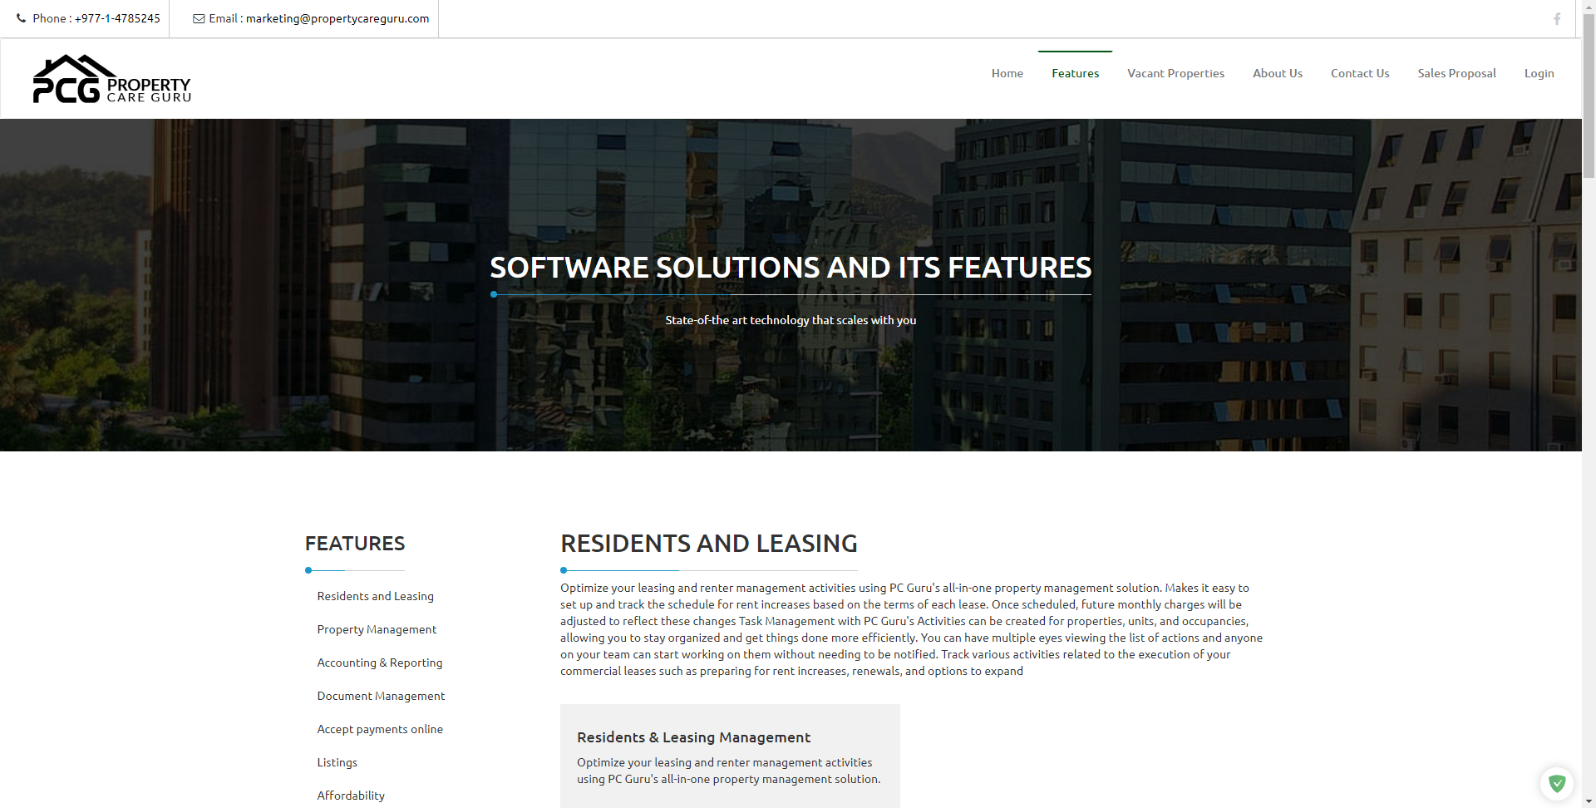

Figure 14: System 5.1

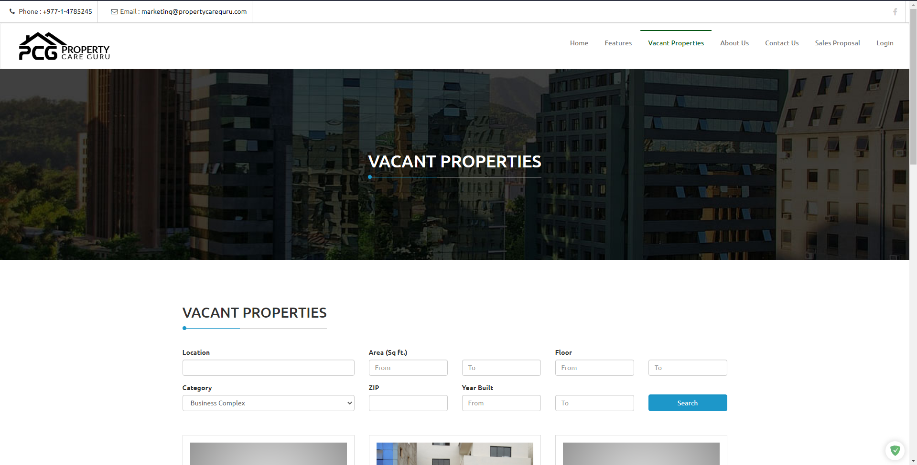

Figure 15: System 5.2

## Similar Systems Comparison

### Comparison Table

|  |  |  |  |  |  |  |
| --- | --- | --- | --- | --- | --- | --- |
| Features | System 1 | System 2 | System 3 | System 4 | System 5 | My Project |
| Availability in Nepal | û | û | û | ü | ü | ü |
| Free to use | û | û | û | ü | ü | ü |
| Rating and Review | û | ü | ü | û | û | ü |
| Map | û | û | û | û | û | ü |
| Push bills | ü | û | ü | û | ü | ü |
| E-payment | ü | û | ü | û | ü | ü |
| Data Analysis | û | ü | û | û | û | ü |

Table 1: System Comparison Table

### Comparison Result

Rent or property management systems are rising in demand each day, especially after the COVID-19 breakout. It has caused an uprise in the number of property management systems available in the market. The comparison done above shows that while there are multiple systems in the rent management domain, none have all the set of features present in my system. The system adheres to the requirements provided by the client. The system is free to use, and available in Nepal. The user can register with a copy of their citizenship, and immediately reap the benefits of the webapp like finding rentable houses via map.

# Development

## Considered Methodologies

### Iterative Waterfall

The waterfall methodology is a linear project management approach, where stakeholder and customer requirements are gathered at the beginning of the project, and then a sequential project plan is created to accommodate those requirements (Project Manager, 2021). The methodology phases do not overlap one another and each phase is carried out sequentially. While being cheap, the project failure chances for long-term projects are maximized in this methodology since it cannot handle client requirement variation very well. Any changes in pre-existing project architecture can result in changes being made to every unit that has already been completed. (Prepinsta, 2020)

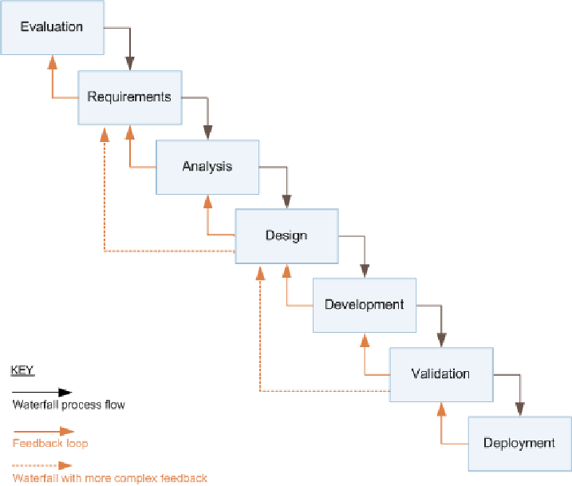

Figure 16: Iterative waterfall model (Ruparelia, 2010)

### Prototyping

A prototype is an early sample, model, or release of a product built to test a concept or process or to act as a thing to be replicated or learned from (Lumitex, 2017). This implies that a prototype is an instrument to evaluate an idea. In prototype methodology, a prototype of the project is made and it is then refined over and over till the app meets client satisfaction. The methodology makes addressing client requirement variation simpler. It is well suited for long-term projects where client requirement is not clear or is prone to frequent changes. (Lewis, 2019)

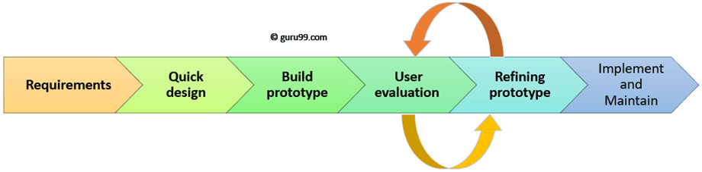

Figure 17: Prototyping Model (Martin, 2021)

### Feature Driven Development

An Agile methodology for developing software, Feature-Driven Development (FDD) is customer-centric, iterative, and incremental, with the goal of delivering tangible software results often and efficiently (PlanView, 2021). As the name suggests, this methodology focuses more on features. In FDD, a feature is expected to be delivered every 2-10 days. The methodology is followed using the below steps:

* Develop overall model
* Build feature list
* Plan by feature
* Design by feature
* Build by feature

Instead of traditional project milestones, FDD uses features to organize its activities. The first three steps are completed initially and the rest of the steps are repeated for every feature. If the client decides to add any more features or changes the requirements, the entirety of the five steps is carried out again in an incremental fashion. (PlanView, 2021)

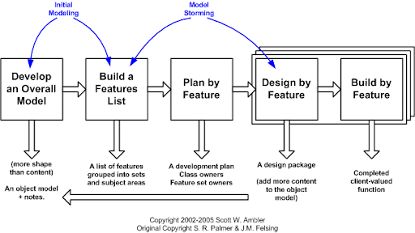

Figure 18: FDD project Lifecycle (Abler, 2021)

## Adopted Methodology (FDD)

Despite being a methodology for large projects, I adopted Feature Driven Development due to the following reasons:

* The methodology requires fewer meetings and is documentation-oriented.
* It uses a user-centric approach with the client in mind.
* It is very scalable and can address the growth of the project.
* It breaks feature sets into smaller chunks and regular iterative releases, which makes it easier to track and fix coding errors, reduces risk, and allows you to make a quick turnaround to meet your client’s needs (Lucid Content Team, 2021).

Further Content: [Appendix A](#_Appendix_A_(Development))

## Phases of Adopted Methodology

### Initiation

In this phase information regarding features that are to be included in the application is identified. The requirements were gathered from the client primarily, while also taking references from other property management websites.

|  |  |
| --- | --- |
| **Task** | **Estimated Duration (days)** |
| Requirement Gathering | 3 |
| Client meeting (Requirement Discussion) | 1 |
| Risk analysis | 3 |
| Client meeting (Terms agreement) | 2 |
| Research on Project and Technologies | 7 |

Table 2: Initiation of Project

### Overall Model

In this phase, a high-level model representing the scope of the project was drawn. Then, a detailed domain model was developed which represents the business logic of the system.

|  |  |
| --- | --- |
| **Task** | **Estimated Duration (days)** |
| Identifying Objects | 1 |
| High Level Overview (Use Case Diagram) | 1 |
| Domain Object Model | 4 |

Table 3: Developing Overall Model of Project

### Feature List

Features are small pieces of client-valued modules of the system. They are usually expressed in the form of “<action<result><object>”, for example: ‘Validate user credentials’, or ‘Render map data’, etc. These are usually completed within two weeks of development time.

In this phase, the features are identified and added to a list. If a feature seems to take more than two weeks to complete, it is broken down into smaller features and added to the list.

|  |  |
| --- | --- |
| **Task** | **Estimated Duration (days)** |
| Identifying Features | 1 |
| Breaking Down Features | 2 |
| Developing Feature List | 1 |

Table 4: Developing Overall Model of Project

### Plan by Feature

After building the feature list, a plan is created which typically dictates the order and ownership of features. This phase includes such planning.

|  |  |
| --- | --- |
| **Task** | **Estimated Duration (days)** |
| Identifying Feature Owners | 0 |
| Planning Feature Sequence | 4 |

Table 5: Developing Overall Model of Project

### Design by Feature

In this phase, the overall model is re-evaluated (also known as conceptual design) and sequence diagrams are drawn for each feature (also known as technical designs).

|  |  |
| --- | --- |
| **Task** | **Estimated Duration (days)** |
| Overall Model Review | 1 |
| Feature Execution planning | 2 |
| Sequence Diagrams for Features | 4 |

Table 6: Developing Overall Model of Project

### Build by Feature

In this phase, a feature is built, code review is conducted and unit testing for the feature is done. If the unit testing succeeded, it is later added to the main build as well. It is an iterative process.

|  |  |
| --- | --- |
| **Task** | **Estimated Duration (days)** |
| Identifying Feature Execution plan | 1 |
| Develop Feature | 3-14 |
| Unit testing / Debugging | 4 |

Table 7: Developing Overall Model of Project

## Survey Results

### Presurvey Results:

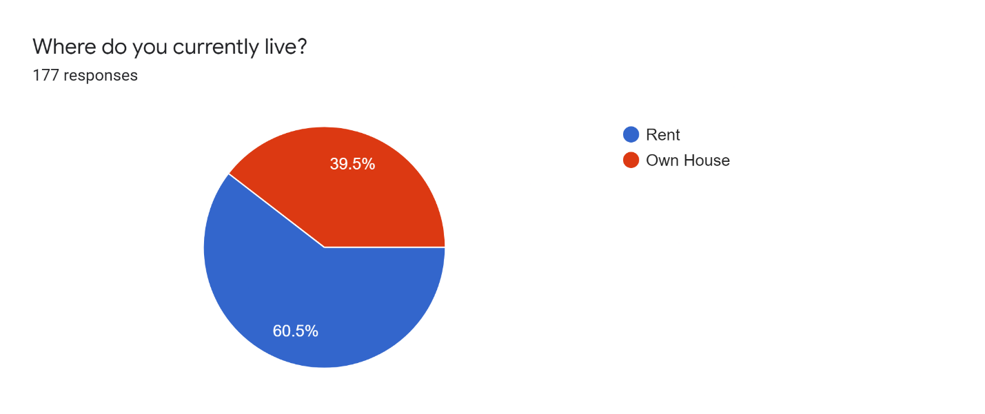

Figure 19: Presurvey result 1

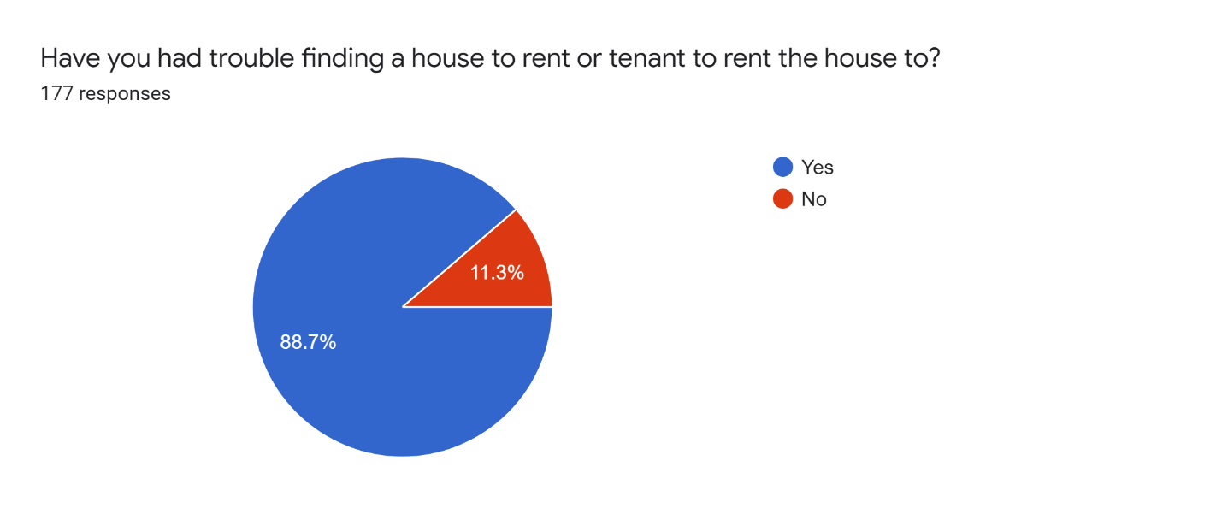

Figure 20: Presurvey Result 2

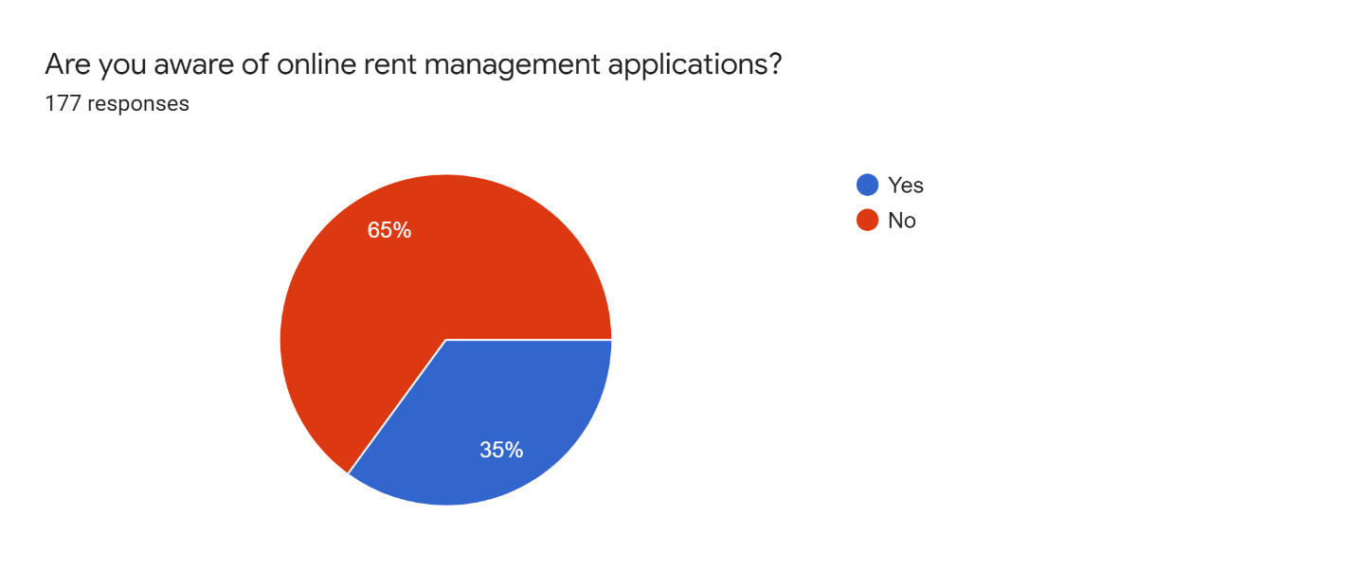

Figure 21: Presurvey Result 3

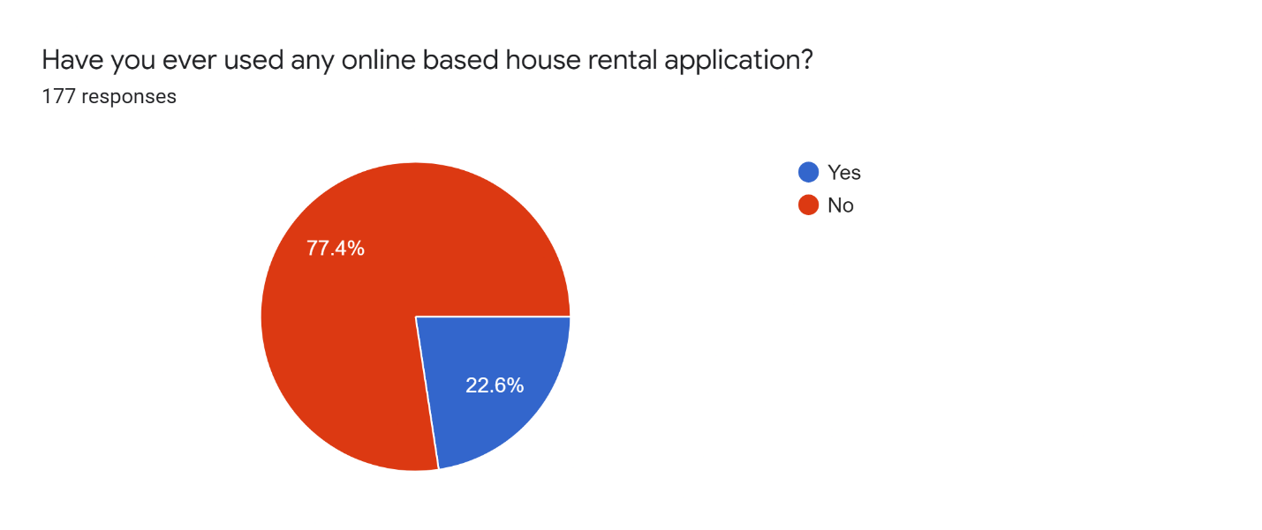

Figure 22: Presurvey Result 4

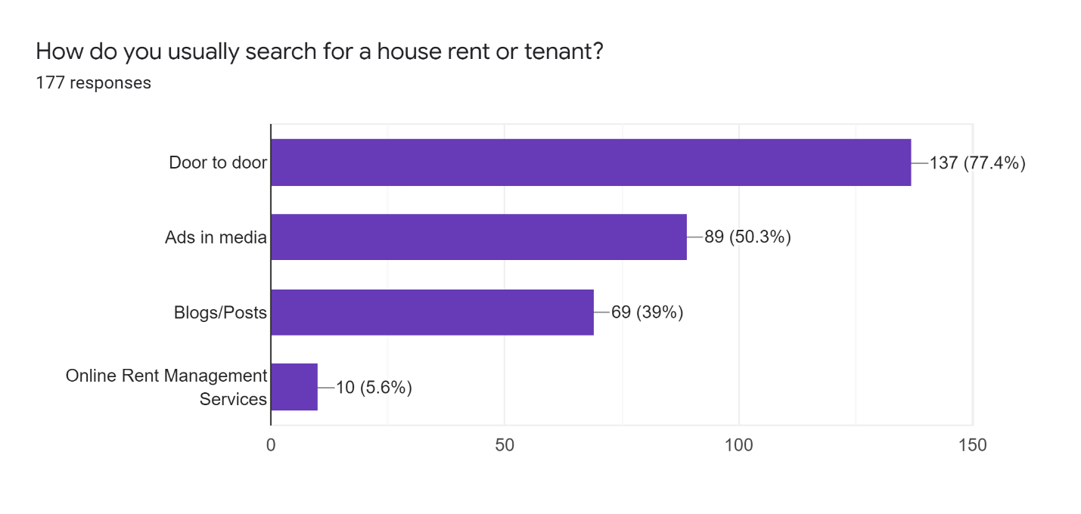

Figure 23: Presurvey Result 5

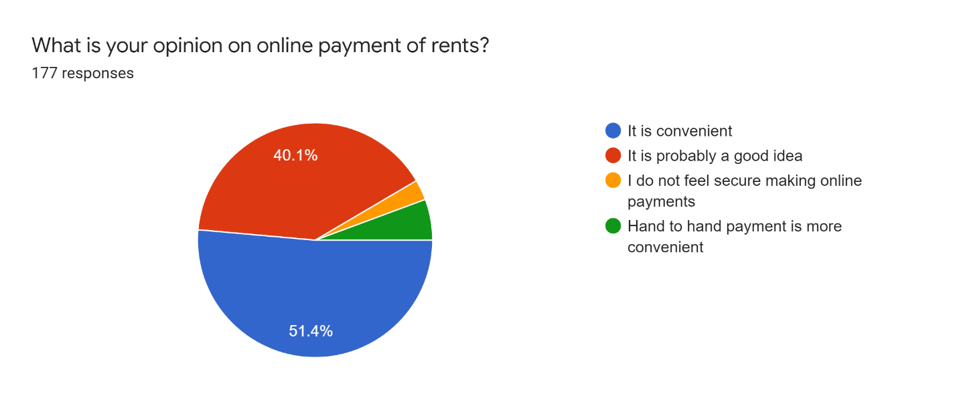

Figure 24: Presurvey Result 6

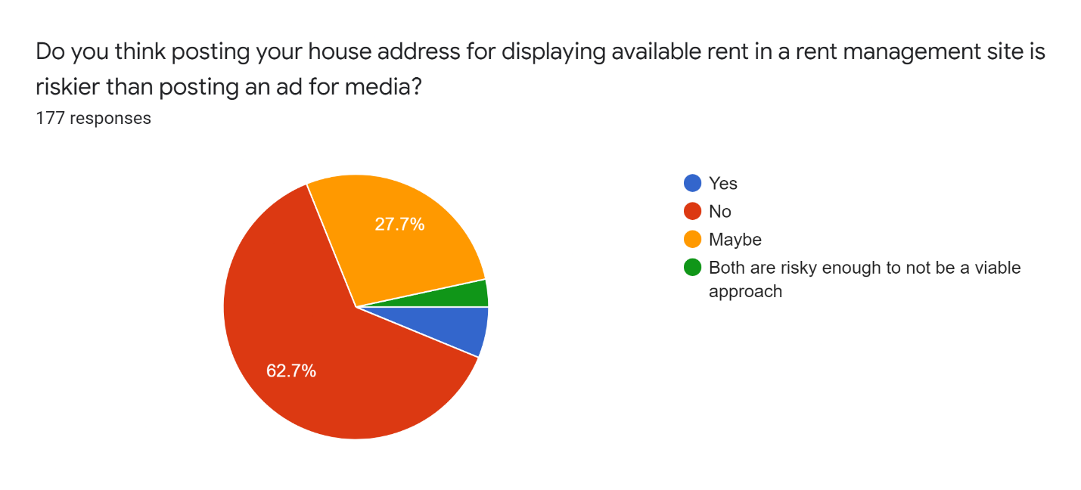

Figure 25: Presurvey Result 7

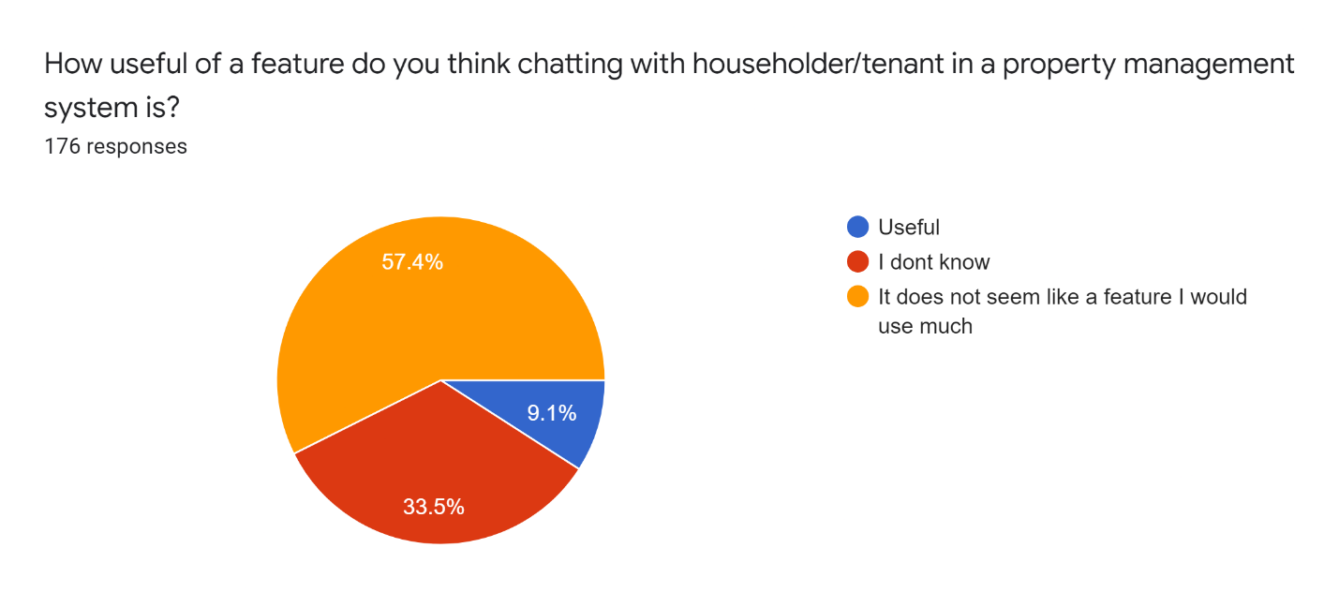

Figure 26: Presurvey Result 8

### Postsurvey Results

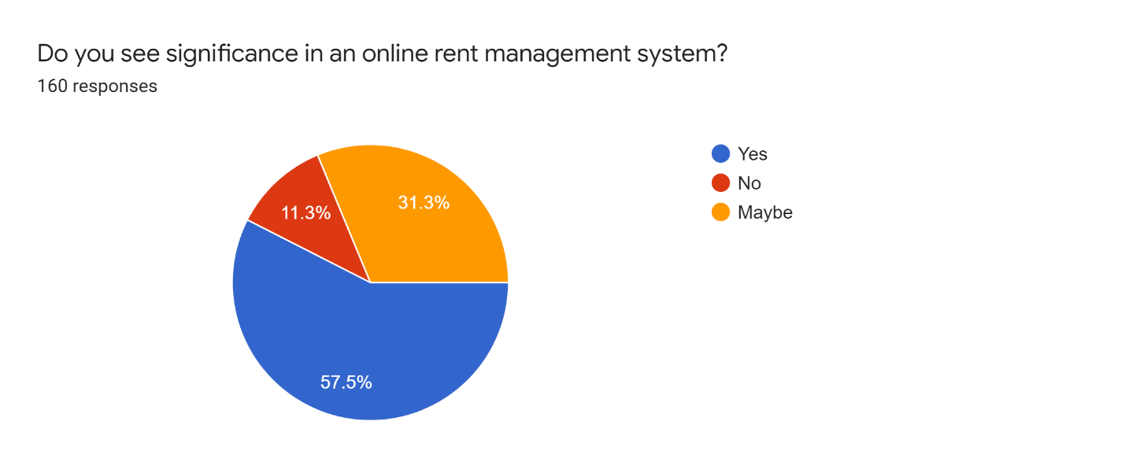

Figure 27: Postsurvey Results 1

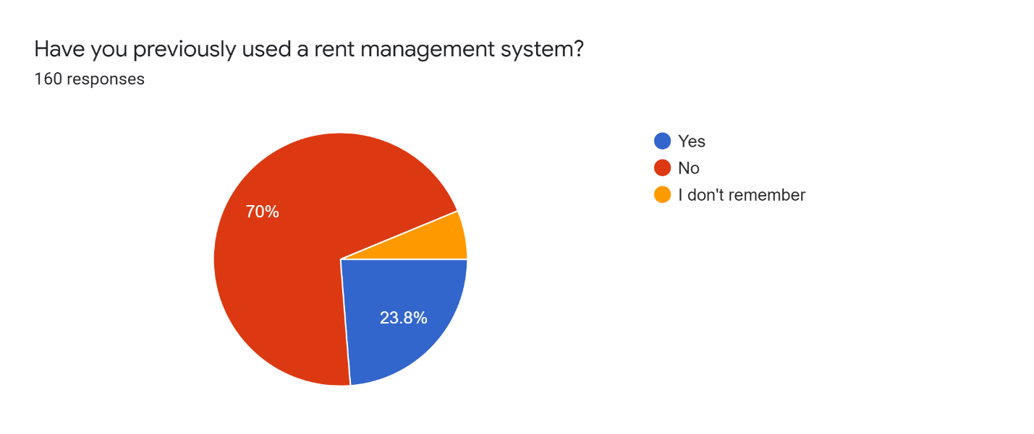

Figure 28: Postsurvey Results 2

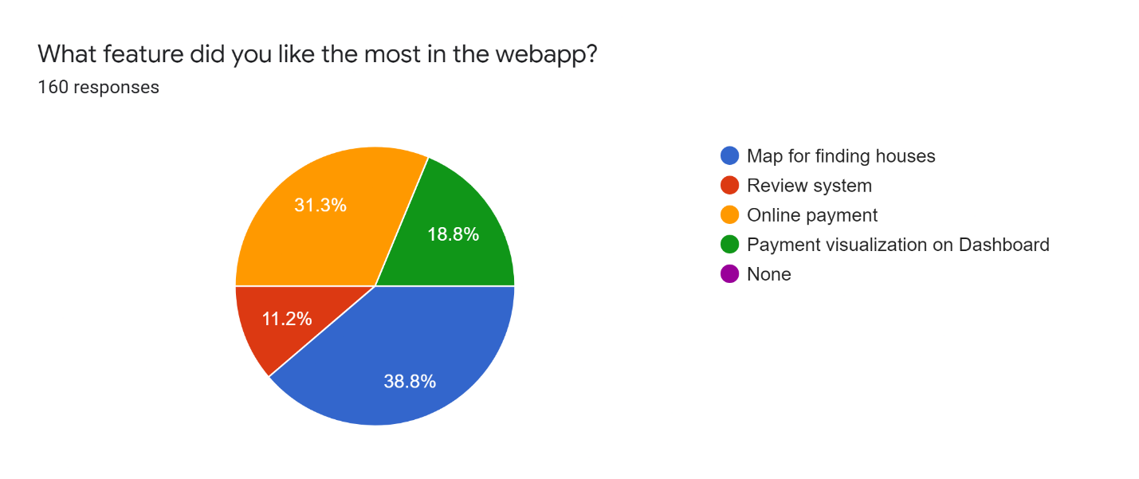

Figure 29: Postsurvey Results 3

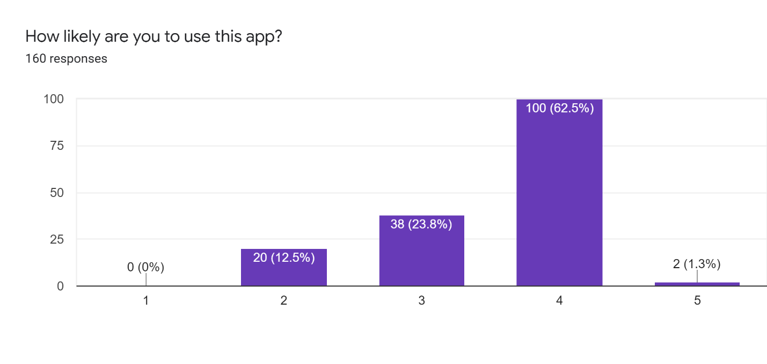

Figure 30: Postsurvey Results 4

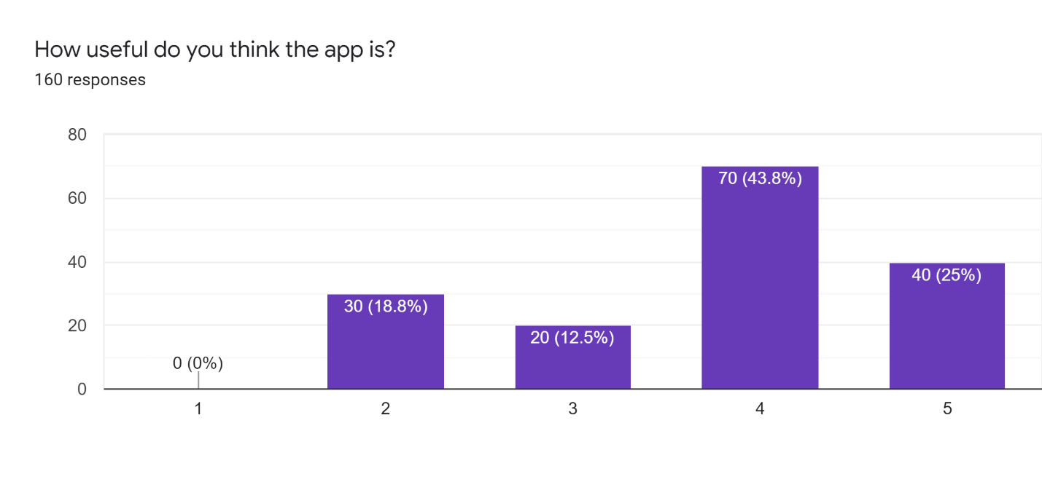

Figure 31: Postsurvey Results 5

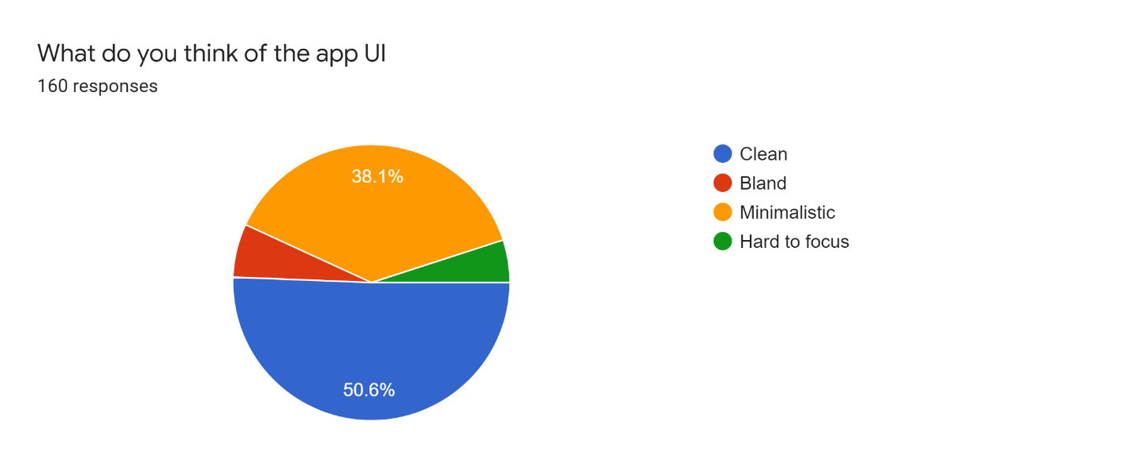

Figure 32: Postsurvey Results 6

### Requirement Analysis

The project is a webapp for managing house rental. Hence, it does not require any specific hardware to run it. Any device with a working internet connection and a web browser can run access the webapp.

Some requirements for running this web application are:

* Smartphone, laptop or smart television
* Stable internet connection
* Web browser: Google Chrome, Firefox

#### Generalized list of requirements

##### Functional

* User can log in to the application
* User can get register for free
* User can get a membership to rent a book
* User can pay online for the books
* User can view all pages without logging into the application

3.6.2.2 Non-Functional

• User can get information about the shop with its details

• User can view a summary of the books

• User can choose different membership plans

3.6.2.3 Useable

• There is navigation available in the header in order to switch intents

• User can send feedback messages from the contact page

• User can add books to Wishlist

• User can review books

• User can add comments

### UI Designs

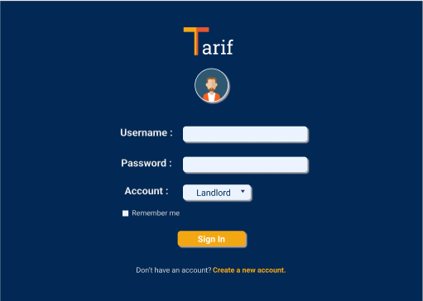

Figure 33: Sign-in page UI

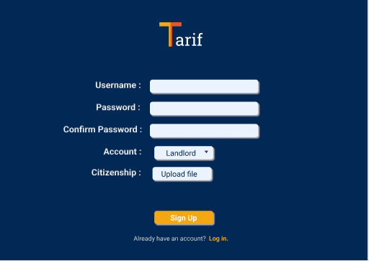

Figure 34: Sign up page UI

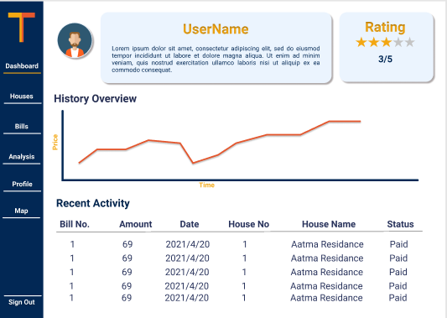

Figure 35: Home Page UI

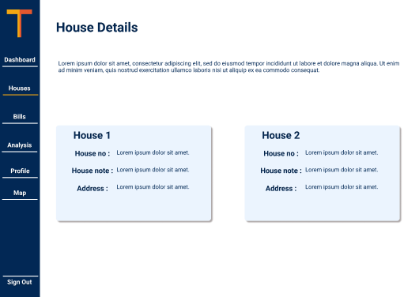

Figure 36: Houses page UI

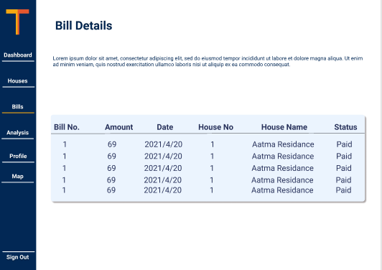

Figure 37: Bills page UI

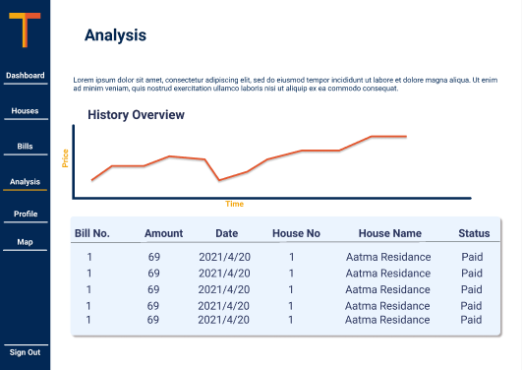

Figure 38: Analysis page UI

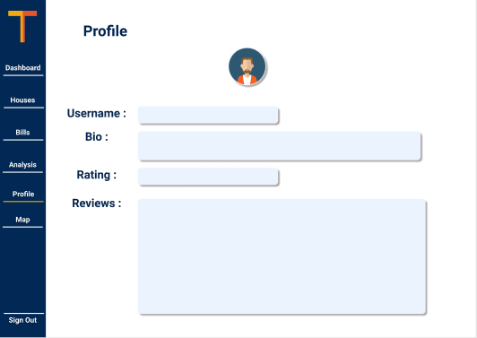

Figure 39: Profile page UI

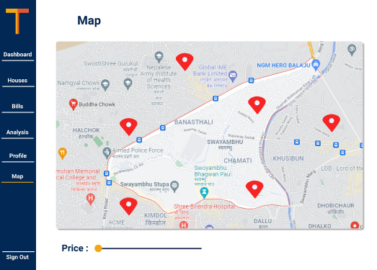

Figure 40: Map page UI

### Use Case Diagram

#### Diagram

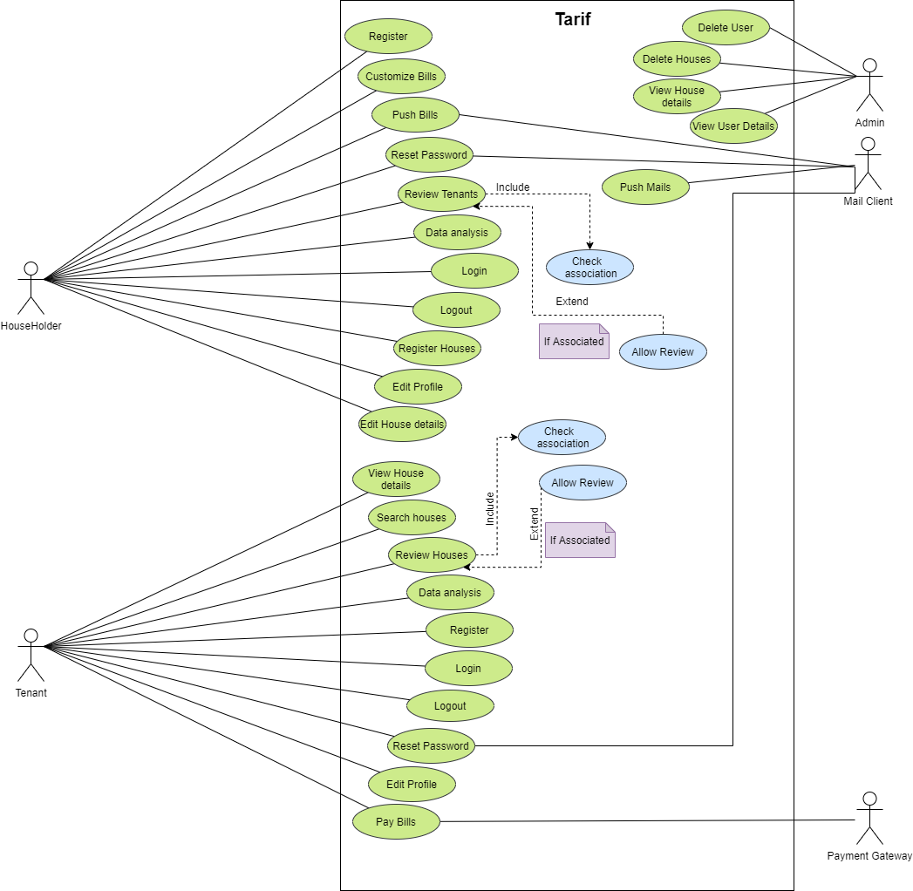

Figure 41: Use Case Diagram

#### High-Level Description

Use Case 1

**Use Case:** Householder Register

**Actor:** Householder

**Description:** The householder enters their details in the system. The system checks if the user is already registered. If not, the registration executes successfully, otherwise, the system gives an appropriate error message to the user.

Use Case 2

**Use Case:** Customize Bills

**Actor:** Householder

**Description:** The householder selects the fields, along with price details, that they want on the bills. The system then generated bills for the house according to this customization made by the householder.

Use Case 3

**Use Case:** Push Bills

**Actor:** Householder, Mail Client

**Description:** The householder enters the bill details and presses the push bill button. The system then calculates the bill, asks the user for confirmation, and sends the details to the mail client. The mail client then pushes the bill to the tenants through their email.

Use Case 4

**Use Case:** Register Houses

**Actor:** Householder

**Description:** The householder fills in the details of their house and registers it in the system. Registered houses can then be displayed as available for rent by the system.

Use Case 5

**Use Case:** Review Tenants

**Actor:** Householder

**Description:** Once a contract with a tenant has been terminated, the householder can then review the tenant. The review consists of a rating out of five and a review text.

Use Case 6

**Use Case:** Data Analysis

**Actor:** Householder

**Description:** The householder views their past data collected in the system in the form of a chart for gaining information.

Use Case 7

**Use Case:** Householder Login

**Actor:** Householder

**Description:** The householder enters their credentials and submits them to the system. The system verifies the credentials and if verified, gives the householder access to the additional features in the system.

Use Case 8

**Use Case:** Householder Logout

**Actor:** Householder

**Description:** The householder logs out of the web app by pressing the logout button.

Use Case 9

**Use Case:** Householder Reset Password

**Actor:** Householder, Mailing Client

**Description:** The householder requests a password reset. Once requested, the mailing system sends a confirmation mail to the householder. After confirmations are done, the householder enters a new password to override their previous password.

Use Case 10

**Use Case:** Householder Edit Profile

**Actor:** Householder

**Description:** The householder presses the edit button. The fields in the profile page then become editable and the householder updates new data in the fields.

Use Case 11

**Use Case:** Householder Edit House Details

**Actor:** Householder

**Description:** The householder presses the edit button. The fields in the house page then become editable and the householder updates new data in the fields.

Use Case 12

**Use Case:** Pay Bills

**Actor:** Tenant, Payment Gateway

**Description:** The tenant presses the pay button. A confirmation message pops up and provides the tenant with a payment option. If the payment method involves e-payment, the payment gateway is activated.

Use Case 13

**Use Case:** Search Houses

**Actor:** Tenant

**Description:** The tenant is provided with a map and a price slider. The available houses matching the given criteria are displayed on the map.

Use Case 14

**Use Case:** Review Houses

**Actor:** Tenant

**Description:** Once a contract with a householder has been terminated, the tenant can then review the house. The review consists of a rating out of five and a review text.

Use Case 15

**Use Case:** Data Analysis

**Actor:** Tenant

**Description:** The tenant views their past data collected in the system in the form of a chart for gaining information.

Use Case 16

**Use Case:** Tenant Register

**Actor:** Tenant

**Description:** The tenant enters their details in the system. The system checks if the user is already registered. If not, the registration executes successfully, otherwise, the system gives an appropriate error message to the user.

Use Case 17

**Use Case:** Tenant Login

**Actor:** Tenant

**Description:** The tenant enters their credentials and submits them to the system. The system verifies the credentials and if verified, gives the tenant access to the additional features in the system.

Use Case 18

**Use Case:** Tenant Logout

**Actor:** Tenant

**Description:** The tenant logs out of the web app by pressing the logout button.

Use Case 19

**Use Case:** Tenant Reset Password

**Actor:** Tenant, Mailing Client

**Description:** The tenant requests a password reset. Once requested, the mailing system sends a confirmation mail to the tenant. After confirmations are done, the tenant enters a new password to override their previous password.

Use Case 20

**Use Case:** Tenant Edit Profile

**Actor:** Tenant

**Description:** The tenant presses the edit button. The fields in the profile page then become editable and the tenant updates new data in the fields.

Use Case 21

**Use Case:** View House Details

**Actor:** Tenant

**Description:** The tenant selects the house on the map. The system then presents the tenant with the details of that particular house.

Use Case 22

**Use Case:** Delete User

Actor: Admin

**Description:** The admin deletes a user from the system.

Use Case 23

**Use Case:** Delete House

Actor: Admin

**Description:** The admin deletes a house from the system.

Use Case 24

**Use Case:** View House Details

Actor: Admin

**Description:** The admin views house information uploaded into the system by the user.

Use Case 25

**Use Case:** View User Details

Actor: Admin

**Description:** The admin views user information uploaded into the system by the user.

Use Case 26

**Use Case:** Push mails

**Actor:** Mail Client

**Description:** The mail client pushes mail to the users when the system calls it to.

Further Content: [Appendix B](#_Appendix_B_(Development)

# References

Abler, S. W., 2021. *Feature Driven Development (FDD) and Agile Modeling.* [Online]   
Available at: http://www.agilemodeling.com/essays/fdd.htm  
[Accessed 19 November 2021].

Fortune Business Insights, 2021. *Property Management Market Size, Share & COVID-19 Impact Analysis, By Component (Software, Services), By Deployment (Cloud, On-Premises), By Application (Residential, Commercial), By End-User (Property Managers, Housing Associations, Real Estate Agents, a,* Pune, Maharastra: Fortune Business Insights.

Lewis, S., 2019. *Prototyping Model.* [Online]   
Available at: https://searchcio.techtarget.com/definition/Prototyping-Model#:~:text=The%20prototyping%20model%20is%20a,or%20product%20can%20be%20developed.  
[Accessed 21 November 2021].

Lucid Content Team, 2021. *Why (and How) You Should Use Feature-Driven Development.* [Online]   
Available at: https://www.lucidchart.com/blog/why-use-feature-driven-development  
[Accessed 21 November 2021].

Lumitex, 2017. *Prototyping Methodology: Steps on How to Use It Correctly.* [Online]   
Available at: lumitex.com/blog/prototyping-methodology  
[Accessed 21 November 2021].

Martin, M., 2021. *Prototyping Model in Software Engineering: Methodology, Process, Approach.* [Online]   
Available at: https://www.guru99.com/software-engineering-prototyping-model.html  
[Accessed 21 November 2021].

PlanView, 2021. *What is FDD in Agile.* [Online]   
Available at: https://www.planview.com/resources/articles/fdd-agile/  
[Accessed 14 November 2021].

Prepinsta, 2020. *Iterative Waterfall Model in SDLC.* [Online]   
Available at: https://prepinsta.com/software-engineering/iterative-waterfall-model/  
[Accessed 20 November 2021].

Project Manager, 2021. *What Is the Waterfall Methodology in Project Management?.* [Online]   
Available at: https://www.projectmanager.com/waterfall-methodology  
[Accessed 20 November 2021].

Ruparelia, N., 2010. *Waterfall model with Royces iterative feedback When referring to the waterfall model.* [Online]   
Available at: https://www.researchgate.net/figure/Waterfall-model-with-Royces-iterative-feedback-When-referring-to-the-waterfall-model-in_fig1_220631422  
[Accessed 21 November 2021].

# Appendix

## Appendix A (Development)

### Gant Chart

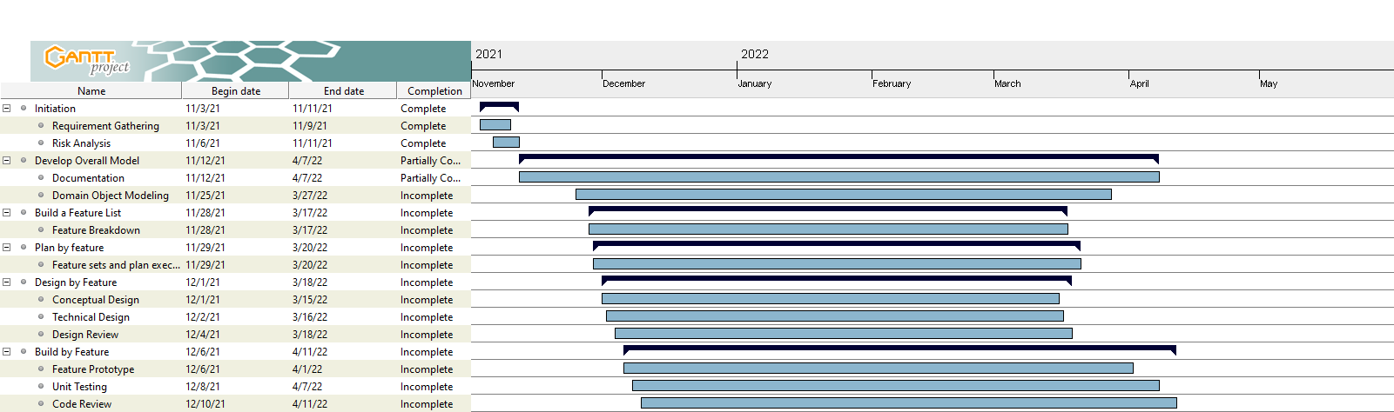

Figure 42: Updated Gantt Chart

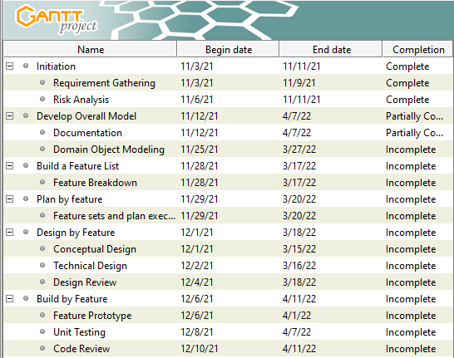

Figure 43: Gantt chart Tasks for Clarity

### Work Breakdown Structure

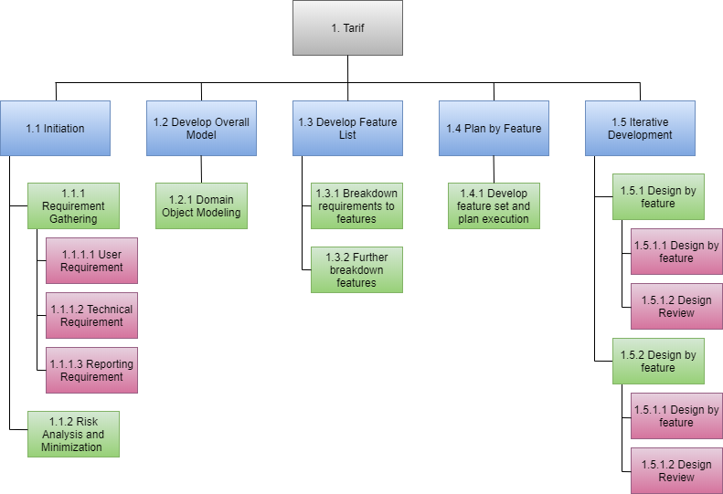

Figure 44: Work Breakdown Structure

## Appendix B (Development Till Date)

### Code Snippets

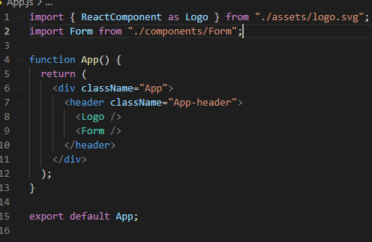

Figure 45: App.js Code

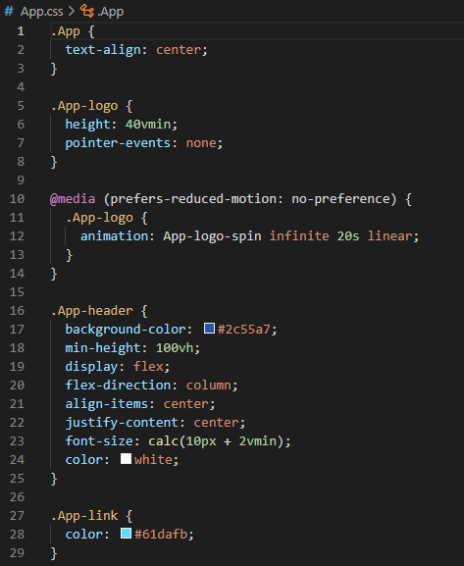

Figure 46: App.css Code

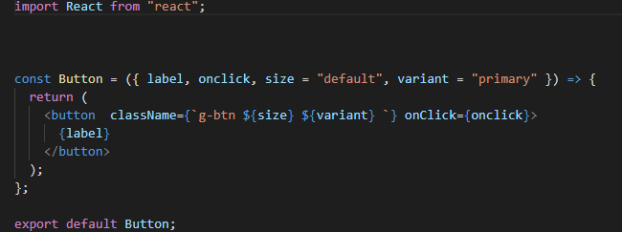

Figure 47: Button Component Code

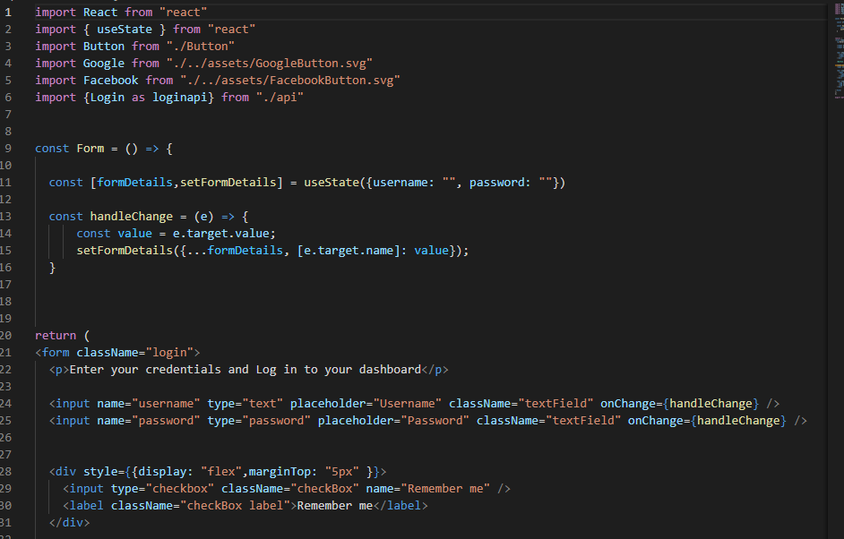

Figure 48: Login form Code

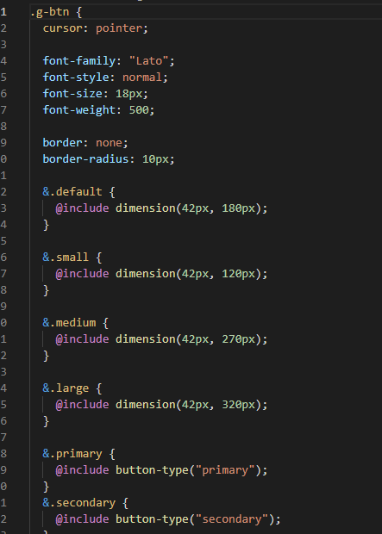

Figure 49: Button style Code

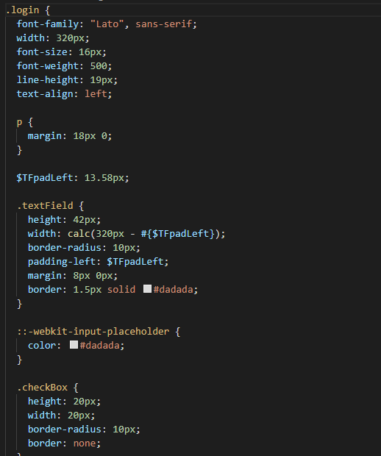

Figure 50: Login Page Code

### Viewable Development

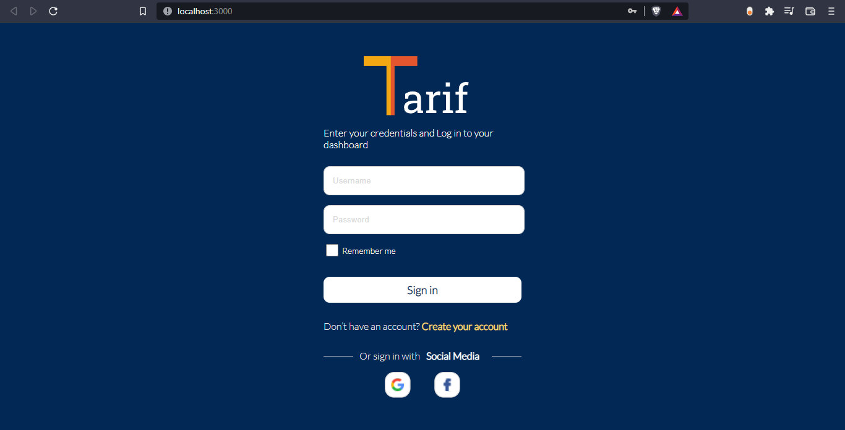

Figure 51: Sign-in page